EMMANUEL IBORO EKPE
SQL ASSIGNMENT 1

- Carry out research where needed on primary key, data types and the where clause in sql.

Qtn: What is primary key: A primary key is a key that uniquely identifies each record in a table.
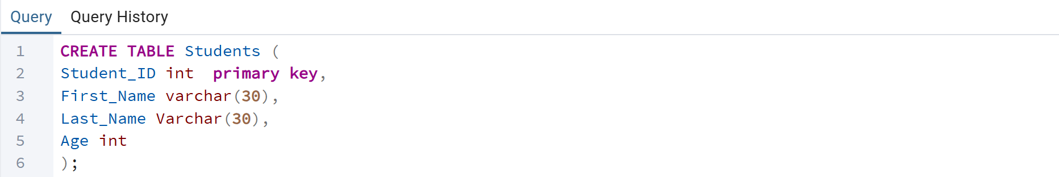

Qtn: What are Data Types in SQL?
Example of different data types: INT, VARCHAR, DATE


Qtn: How is the WHERE clause used in SQL?
It filters records based on a condition.

Qtn: What are Comments in SQL?
--Single-line comment uses two dashes –
-- Multi-line comment uses /*…*/

